# People Manager review worksheet

|  |  |  |  |  |  |  |
| --- | --- | --- | --- | --- | --- | --- |
| **Employee name: Mark Atkinson** | | | **Date:** | | | |
| List Performance Goals Below | | Star Rating  *(Click the Stars below to indicate number of stars for each goal.)* | Weighting to total 100% for each section | | Weight based on role to total 100% | |
| **Performance Goals** | **Goal 1:** **Pursue Operation Excellence:** **Deliver on QA Foundational Initiatives**  **Comments:** Employee self-assessment |  | 20% | 100% | 50% | 100% |
| **Goal 2:** **Pursue Operation Excellence:** **Maintain and support Automation standards across assigned teams, and any others I can help with**  **Comments:** Employee self-assessment |  | 20% |
| **Goal 3: Pursue Operation Excellence:** **Continue building a community of practice that embodies inclusion, sharing and support across teams.**  **Comments:** Employee self-assessment |  | 20% |
| **Goal 4: Deliver to our Customers: Enhance automation capabilities in conjunction with ongoing enterprise initiatives**  **Comments:** Employee self-assessment |  | 20% |
| **Goal 5**: **Pursue Operational Excellence: Develop expanded skills and expertise in tooling and technologies**  **Comments:** Employee self-assessment |  | 20% |
| **Overall Comments Goals** | **Overall Comments for Goals:** Employee self-assessment |  |  |
| **Competencies/ Employee behaviors** | **Deals Effectively with Change**  **Comments:** Click or tap here to enter text. |  | All Competencies are weighted evenly. | | 50% |
| **Creates Accountability**  **Comments:** Click or tap here to enter text. |  |
| **Focuses on the Customer**  **Comments:** xxx |  |
| **Drives for Operational Excellence**  **Comments:** Click or tap here to enter text. |  |
| **Drive to Results**  **Comments:** Click or tap here to enter text. |  |
| **Fosters Development**  **Comments:** My approach and delivery with team staff is always and consistently focused on personal development, improvement, and empowerment. I see hesitation from time to time and feel is valuable to the organization that I lead and demonstrate to staff what they can ask for, what they can learn and develop on their own, and how they should convey these issues with their management organizations. |  |
| **Overall Comments Competencies** | **Overall Comments Competencies:** Click or tap here to enter text. |  |

Overall Comments: Click or tap here to enter text.

## Rating Goals and Competencies

**For additional information Performance Goals and Goal Rating and Competencies, please visit the** [**Performance Management Portal page**](http://departments/peopleorg/home/Pages/Performance%20Management%20and%20Rewards.aspx)**.**

**Rating Goals**

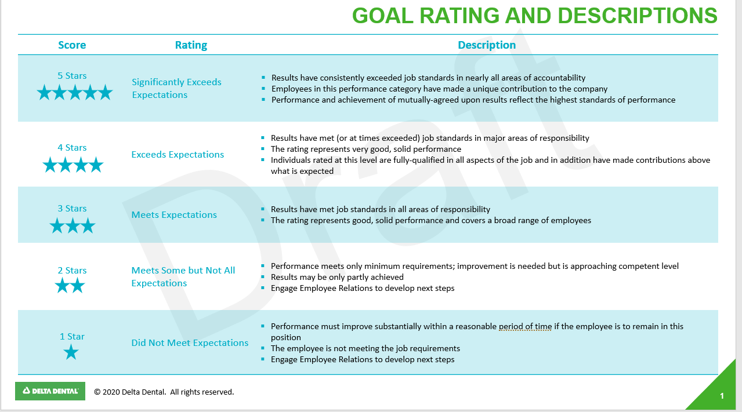

**Ratings Competencies**

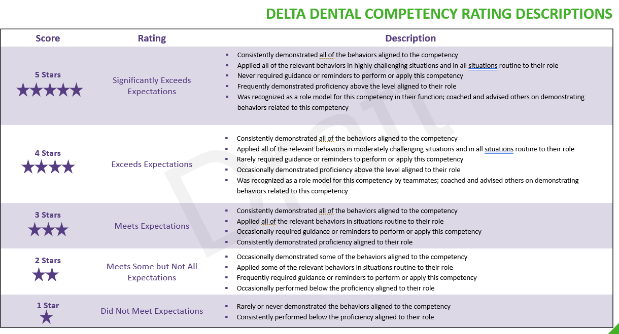

### Leadership behaviors definitions continued